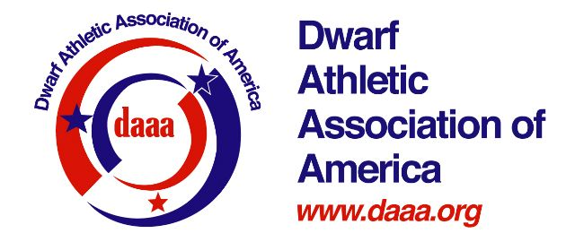
Dwarf Athletic Association of America Code of Conduct for 2018 National Orlando Games
The Dwarf Athletic Association of America (DAAA) encourages people with dwarfism to participate in sports regardless of their level of skills. As the focus of DAAA is dwarf athletes, membership in DAAA provides the opportunity for individuals with dwarfism to reach their potential in sports.
To this end, I pledge to uphold the spirit of this Code of Conduct which offers a general guide to my conduct as a member of DAAA when attending National and Regional games or any DAAA sanctioned National, Regional or Local competition. I recognize that this Code of Conduct does not establish a complete set of rules, which prescribes every aspect of appropriate behavior.
By signing the Code, in its unaltered form, I:
- Agree to participate as a member of DAAA;
- Agree to abide by the Code of Conduct and the attached Grievance Procedures, which will be used by DAAA to resolve any alleged violations of the Code occurring between the beginnings of competition to the end of the competition;
- Agree to submit any dispute to DAAA, pursuant to the Grievance Procedures.

I have familiarized myself with the Code, and understand that acceptance of its provisions as written
is a condition of membership in DAAA.
I pledge to
      - ● Act in a sportsmanlike manner consistent with the spirit of fair play and responsible behavior;
      - ● Not violate the laws of the state and city in which the national, regional and local competitions are held;
      - ● Not use any medication or substance on the International Paralympic Committee (IPC) banned substance list and not violate any procedures relating to the use of banned substances and not use substances or procedures in violation of the IPC and/or DSO Anti-Doping program;
      - ● Refrain from the use of, or the providing of, alcohol or drugs in violation of local, state and federal law;
      - ● Refrain from the use of, or the providing of, alcohol or drugs at the athletic venues of DAAA competitions;
      - ● Respect the property of others whether personal or public;
      - ● Respect members of DAAA, other teams, spectators, and officials, and engage in no form of verbal, physical or sexual harassment or abuse;
      - ● Respect the rules of the local Organizing Committee, including DAAA and LPA committee rules;
      - ● Refrain from the use of unauthorized devices or equipment or providing unauthorized devices or equipment to others;
      - ● Abide by the competition rules of DAAA Sport Policies, Procedures and Rules Manual, including those rules of the National Governing Body for each sport;
      - ● Refrain from competition if I am bleeding from the mouth or nose or have an uncovered wound;
      - ● Remember that at all time I am an ambassador for DAAA and the Disabled Sports movement.

Affirmation: I have read, understand and accept this Code of Conduct, including the attached Grievance Procedures. I agree to the results, guidelines, jurisdiction and procedures stated in these documents as a condition of participating as a member of DAAA.
Signature ___________________________________ Today’s Date ________________________
Printed Name ________________________________
Parent/Guardian of DAAA member under 19 years of age:
Signature ___________________________________ Date ________________________
Relation (parent or guardian) _______________________________________________

Liability Waiver and Release
In consideration of being allowed to participate in any way in the DAAA National 2018 Orlando Games athletics/sports programs and related events and activities, I the undersigned acknowledge and fully understand that each participant will be engaging in activities that involve risk of serious injury, including permanent disability and death, and severe social and economic losses which might result not only from their own actions, inaction's or negligence, but the actions, inaction's or negligence of others, the rules of play, or the condition of the premises or of any equipment used.
Further, I have fully considered and understand the risks that I could be physically injured as I prepare for, participate in and travel to and from the programs and events of the DAAA National 2018 Orlando Games. I assume these risks. Further, I know of no reason why my participation in this program or its events should be exceptionally or unusually hazardous to my health. I assume ALL of the foregoing risks and accept personal responsibility for the damages following such injury, permanent disability or death.
I agree to release, waive, discharge and indemnify the DWARF ATHLETIC ASSOCIATION OF AMERICA, its affiliates, and their respective administrators, directors, agents, coaches, game officials, employees, participants, sponsors and volunteers from any and all liability to themselves, their heirs, and administrators for any injuries, including death, damages, losses or expenses.
I HAVE READ THE ABOVE LIABILITY WAIVER AND RELEASE AND UNDERSTAND THAT I HAVE GIVEN UP SUBSTANTIAL RIGHTS BY SIGNING IT, AND I SIGN IT VOLUNTARILY.
Signature: _______________________________________________ Date:________________________
(or guardian if under 18 years)

Media Waiver Further, I hereby give my permission to the DWARF ATHLETIC ASSOCIATION OF AMERICA and its designated agents to take and use my likeness, photograph, video, voice, words and name (“Likeness”) for publication or reproduction in any news reporting, advertisement, public relations or fundraising efforts of the association, its programs, sponsors or agents, in any media now known or hereafter created, without the right to review its use and without payment of any compensation. My Likeness may not be used to endorse any commercial products or services.
I HAVE READ THE ABOVE MEDIA WAIVER AND UNDERSTAND THAT I HAVE GIVEN UP SUBSTANTIAL RIGHTS BY SIGNING IT, AND SIGN IT VOLUNTARILY.
Signature: ______________________________________________ Date:_________________________
(or guardian if under 18 years)

